Name of Activity: Dropbox Assignment
List the related Performance Objective:
- Use Dropbox to find team documents.
Name the location(s) where the activity will be carried out, including virtual location(s):
- The document will be found in a Dropbox folder
- The screenshot will be uploaded via a TalentLMS Assignment unit
Due Date: By the end of the first week
Time the task will take: 5 minutes
A successful product or process looks like: a screenshot of the document (SOP – Submitting Service Desk Tickets) uploaded to TalentLMS
Here are the steps you must take to successfully complete the task:
- Open your Dropbox desktop app.
- Follow the file path to reach the document SOP - Submitting Service Desk Tickets:

From a PC: C: > Users > username of account > Dropbox (Daxko) > Services Operations > 1. Internal SOPs > Salesforce > SOP - Submitting Service Desk Tickets.docx

From a Mac: Macintosh HD > Users > username of account > Dropbox (Daxko) > Services Operations > 1. Internal SOPs > Salesforce > SOP - Submitting Service Desk Tickets

- Open the document: SOP - Submitting Service Desk Tickets.

- Take a screenshot of the document (a partial screenshot is acceptable):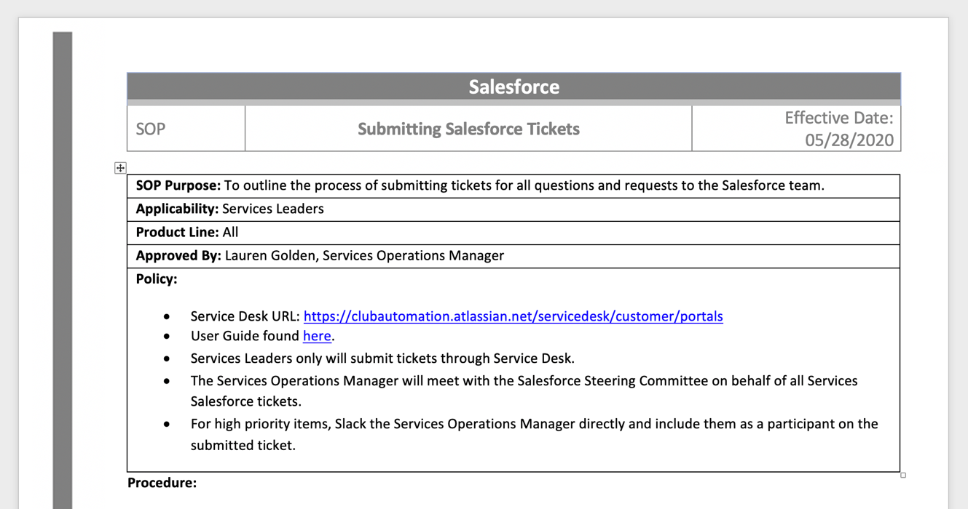

- Submit the Screenshot to the Dropbox Assignment unit in the TalentLMS course:
  - Clicking Upload a File
  - Click Upload Your Reply
  - Browse your files and select the screenshot (gif, jpg, jpeg, png: 10MB or less) and click Open (the assignment will show as “Pending” until the course instructor has checked it.


