**List the related Performance Objective:**

* Use Zoom, Outlook, Slack to complete onboarding sessions, and for your role.

**Name the location(s) where the activity will be carried out, including virtual location(s):**

* The Zoom meeting will be scheduled in Outlook
* The screenshot will be uploaded to Slack along with Slack reactions to the posts of your co-New-Hires
* Your electronic signature entered into the Text reply box in TalentLMS Assignment Upload

**Due Date:** By the end of the first week

**Time the task will take:** 10-15 minutes

**A successful product or process looks like:**

1. A screenshot of you attending the Zoom meeting you scheduled uploaded to Slack (with an @Slackhandle mention of the designated Services Operations member, like @Britta or @ Lo)
2. Reactions left for other New Hire’s posts of the same assignment.
3. Your electronic signature entered into the Text reply box in TalentLMS Assignment Upload

**Here are the steps you must take to successfully complete the task** (*Create a Meeting, Attend a Meeting, Participate in the Slack Channel, and Submit Your Electronic Signature to Indicate Completion*):

**Create a Meeting**

1. Open Outlook
2. Click the Calendar button at the bottom of the left sidebar.
3. Click the Meeting in the toolbar (upper right).
4. In the “To” line, enter the name(s) of potential meeting attendee(s)—as you type their name the email address/full name should be offered, and you may select the person with whom you would like to meet and press Enter/Return.
5. Enter the Subject as “Zoom Practice”
6. Enter the time for the meeting
   1. Select the Duration
   2. Calendar date
   3. Time
7. Click Scheduling in the tool bar (upper right).
   1. Verify that the time you have chosen is available on the calendar(s) of the invitation recipients.
   2. If necessary, drag the blue box to select a new time.
   3. Keep the default for Show As: Busy
8. Click Appointment in the tool bar (upper right).
9. Use the Zoom plug-in from the toolbar at the top of the screen labeled “Add a Meeting” (if you are not signed into Zoom, you will be prompted to sign-in)
10. When the Meeting details window pops up, click Save at the lower right.
11. Verify the details you have added and Click Send in the tool bar (upper right).

**Attend a Meeting**

1. At the appointed time, open the meeting from your Outlook calendar
2. Use the join link to jump into the meeting
3. If the Open zoom.us window appears, click the Open zoom.us button.
4. Click Join with Computer Audio (you can test the speaker and microphone if you like)
5. If not automatically enabled, click Start Video in the Zoom toolbar at the bottom left of the screen.
6. Say hello to your participants! Take a screenshot of your Zoom meeting (There are style points! But the “Who’s Line is it Anyway?” type that don’t really matter)
7. When you have your screenshot, tell your participants goodbye and click End Meeting in the power right. If the popup appears, click End Meeting for All.

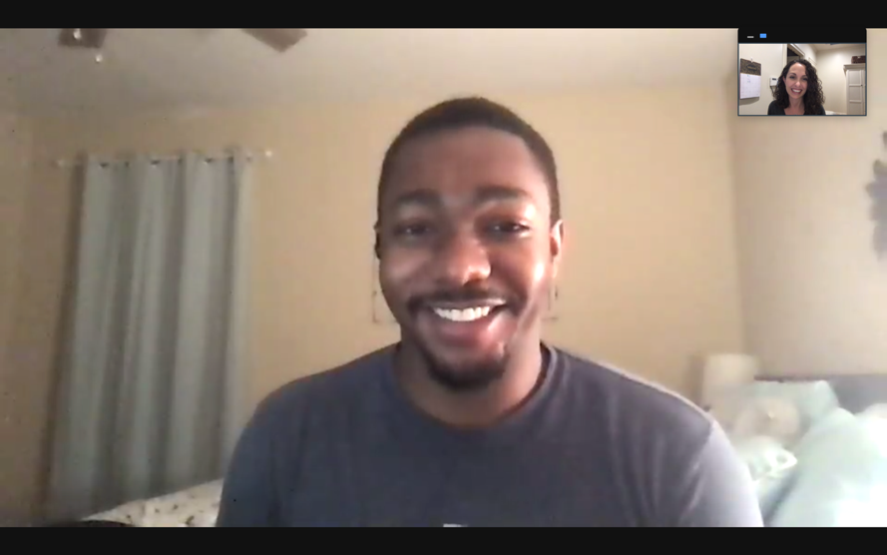

**Participate in Slack Channel**

1. Open Slack and navigate to the Services New Hire Slack channel (left sidebar, listed under Channels).
2. In the message bar at the bottom, say hello to the channel and give the names of your fellow meeting participants. If they are among those in the channel, you can mention them (@Slackhandle). **Also, include the @Slackhandle of the designated Services Operations team member, for example: @Britta or @ Lo**
3. Click the Attach file button in the far lower right.
4. Select Your Computer, find and select the screenshot file, then click Open. This will upload the screenshot to your draft message.
5. Click the green Send message button on the far, lower right. This will post your message.
6. React to other team member uploads with the emoji of your choice
7. Plan to return to the channel a few times to see new uploads from your New Hire teammates.

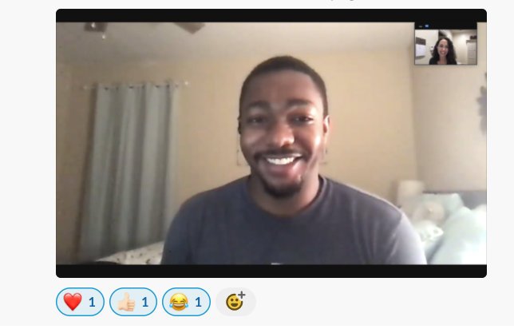

**Submit Your Electronic Signature to Indicate Completion**

Submit your electronic signature (by typing your name) in the *Text reply box* in the TalentLMS after you have completed your Slack participation:

* 1. Click **Text reply**
  2. Type your name
  3. Click **Send your reply and continue** (the assignment will show as “**Pendin**g” until the course instructor has checked it)