Services Onboarding  Program Guide  (New Hire Coach) | Self-paced Training & Assignments
Social Learning | New Hire Coach Program

  - New Hire Onboarding
Is planned to increase employee engagement and retention, decrease the on-ramp time, build a stronger We Over Me culture, and increase self-determination in New Hires.

What You’ll Do
The New Hire Coach Plan

New Hire Coach Duties:
Week 1
- Monday: Meet new hire (in-person or virtually) for lunch—establish rapport, explain your role, discuss your availability
- Throughout the week: as needed, assist new hire in acclimating to Daxko, encourage social learning (be a resource for assignments: Buffalo Research, Growth Mindset challenge, Your Place on the Org chart)
- Friday: review NH self-eval and goal-setting before meeting; meet at end of day to review onboarding experience and introduce team training
Weeks 2-4 (and beyond, if possible)
- Debrief NH when training is self-paced (SPT should not be a completely independent experience); as needed, suggest additional resources (people, tools, documents)
- Shadowing:
  - NH Shadows Coach: Coach provides expert example – shows how but also says why (teaches thought processes and decision-making)
  - Coach Shadows New Hire: Coach observes NH on mock and initial customer interactions (audio, video, in-person, email) gives specific feedback, encourages NH to set their own goals
- Promote Kaizen: regular self-eval & eval of NH + give feedback on NH self-eval, facilitate goal-setting
- Foster self-determination in NH (give choice when possible, provide structure & guidance that fades w/NH development, promote a sense of belonging and connection)
- Meet daily (or 3-4 times) per week for short 10-15 minute Coaching Check-ins (see next page)
New Hire Duties:
- Take ownership of learning: do the work, ask questions, take notes, be responsible & proactive
- Participate in growth: use self-eval & feedback to set goals; pursue goals
- Use reflection: think about/interact with the content to promote learning

Coaching Check-ins (15 min., daily, if possible)

NH: Slack the 3 C’s prior to meeting
  - Celebration: What went well with training?
  - Confusion/Curiosity: Was anything confusing to you today? What are you curious about?
  - Confidence: How confident do you feel moving forward into tomorrow? What are your goals?
Coaching Check-in Meeting
New Hire: review the 3 C’s from Slack, 1 minute on each
Coach (the 4 C’s): 1-2 minute response on each + commitment to return to outstanding items
    - Celebration: Celebrate/relate with what went well.
    - Confusion/Curiosity: Clarify + commit to more time/resources as needed
    - Confidence: Discuss confidence—check/set goals here—reaffirm or re-direct as needed
    - Connections: As needed, make connections for them. Options:
      - Connect ideas together (maybe part of clarifying what is confusing)
      - Connect them with resources—documents, videos, people…
      - Connect what they are doing to Critical Behaviors to show relevance and evaluate progress
      - Revisit the “Celebration” piece and encourage them in the Connections they made on their own, in their learning or with people or processes

Why You’ll Do It
New Hire Coaching Goals
For the Coach: Make Your Thinking Visible
For New Hire: Development of Critical Behaviors + Skills Development > Growth toward Expertise

Critical Behaviors are what we hope to see in the performance environment (what it looks like when people are doing their job well)
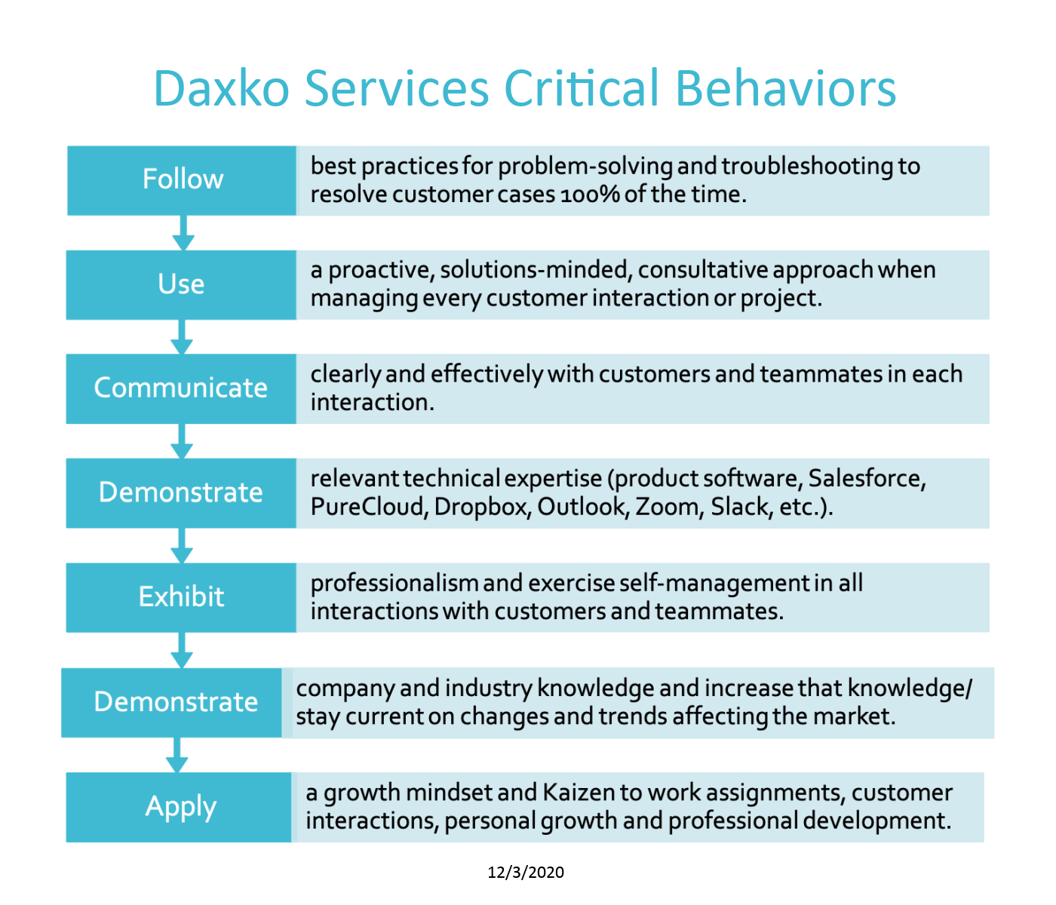

Development and Performance of Critical Behaviors impacts organizational goals—drives our success.
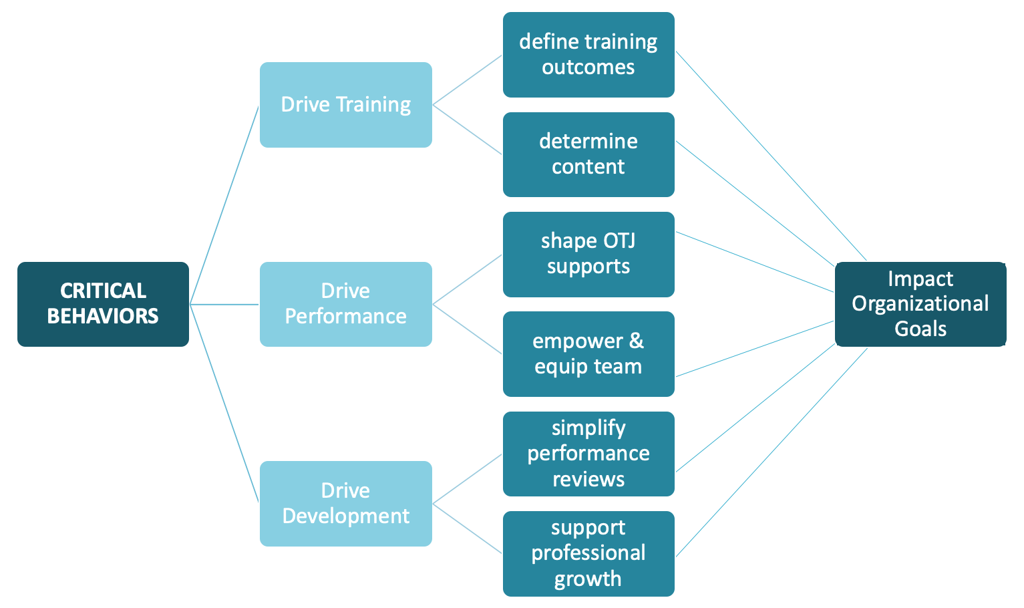

How You’ll Do It
Desired Outcome: Skill Development (Hard skills + Soft Skills = Growth Towards Expertise )

Key Opportunities:
- Reveal implicit/tacit knowledge (surface knowledge and processes that are stored in the minds of experts, which are not explicitly expressed)
- Encourage growth and self-determination
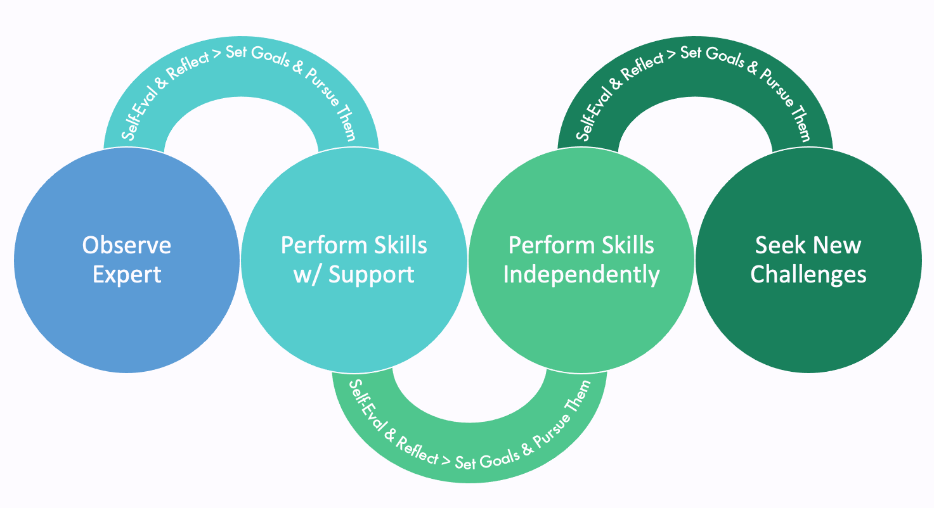

Growing Expertise Model
Intentional Movement from Observation > Practice > Performance (toward Expertise)

Process:
- Observe Expert (where expert reveals insider info)
- Perform Skills with Support (from expert or other resources)
- Perform Skills Independently (unassisted)
- Self-evaluate and reflect (on-going, throughout)
- Set goals and pursue them (on-going, throughout)
Similar to DO teachback process, steps 1-3, plus steps 4-5:
https://www.dropbox.com/s/dwc8gasx3ig3rmf/Walkthrough%2C%20Runthrough%2C%20Teachback%20Info.docx?dl=0
Key Components:

- Cognitive Apprenticeship* on the Team
  - Make knowledge explicit; record/write down team standards: time use and management, tools, culture, language, decision-making, processes, attitudes and goals
  - Make self-eval and coach review regular part of training
  - New hire participates in goal-setting
- Shadowing Opportunities (supportive observation of the new hire)
  - Mock/Live Audio Calls
  - Mock/Live Video Calls
  - Mock Chats and Case Audits
  - Email Correspondence
  - In-person presentations
- Formal Coaching Follow-up after Training Courses – debrief, give context, answer questions, provide clarification, and suggest additional resources (people, tools, or documents)
- Reflection/Discussion (encourage new hire to re-organize new knowledge and experiences to make learning personally meaningful)
- Impromptu, as needed
- Scheduled: use standard reflection or self-eval questions as a guide, following specified learning events or at regular intervals? (teaching self-eval, continuous improvement)
- Self-determination - highlight opportunities to intentionally encourage **
- Autonomy – by giving choice, allowing them to take action, determine direction
- Competence – by providing structure/guidance that fades to independence, providing timely feedback
- Relatedness – by fostering a sense of belonging and connection
- On-going evaluation
- Reflective self-eval + Structured eval (for both Coach and New Hire)
- Informal feedback
- Continuous improvement (responses to feedback tracked/improvements made as a result of feedback),
- Shared feedback (Services Operations wants to be in this feedback pipeline)

* More about Cognitive Apprenticeship (the foundational learning theory) here.
** More about Self-Determination Theory (the critical motivational theory) here.

Note: Mentor vs. Coach:
The terms mentoring and coaching often get used interchangeably, which can be misleading. While similar in their support of someone's development, they involve very different disciplines in practice.
Mentoring consists of a long-term relationship focused on supporting the growth and development of the mentee. The mentor becomes a source of wisdom, teaching, and support, but not someone who observes and advises on specific actions or behavioral changes in daily work. The mentee drives the agenda, goals, and progress.
Coaching typically involves a relationship of finite duration, with a focus on strengthening or eliminating specific behaviors in the here and now. Coaches help professionals correct behaviors that detract from their performance or strengthen those that support stronger performance around a given set of activities. Coaches evaluate professionals, set the pace and goals, and offer corrective criticism as needed.
https://www.digitalhrtech.com/peer-mentoring/

FYI: First Week Details
ONBOARDING COURSES (SELF-PACED)

Tuesday Morning
 | Administrative Tools & Policies will explore some of the technological tools that serve the Daxko Nation. Okta SSO, OpenVPN, ADP, and Dropbox support security, communication, collaboration, project management, knowledge sharing, and customer service across product lines and roles Daxko.
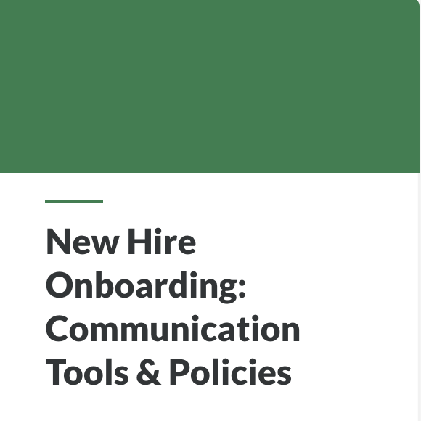 | Communication Tools & Policies will explore the tools we use at Daxko to communicate with team members and customers by creating individual and group messages and emails, creating and attending/hosting meetings, and organizing/sharing your calendar
Tuesday Afternoon
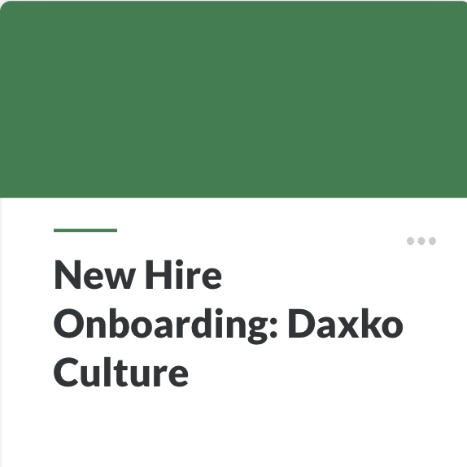 | Daxko Culture. In this course, you'll get a primer on our amazing and unique workplace. You'll explore Our Vision, Our Who, Our What, Our How, along with the phrases, terms, and titles that will make you feel a part of the Daxko culture, right away.

Wednesday Morning
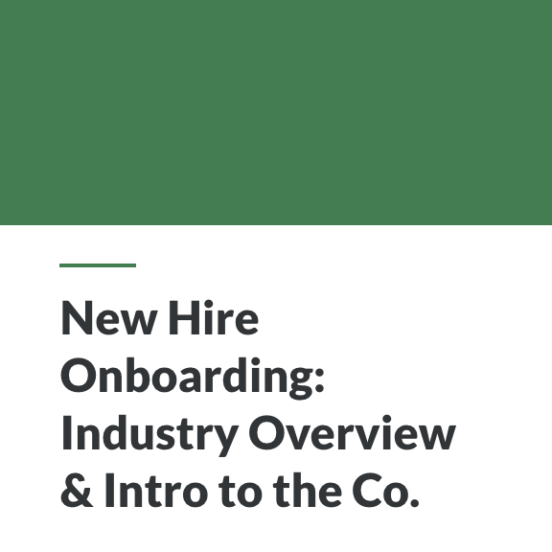 | In this course, Industry Overview & Introduction to the Company, we explore Daxko place in the Industry. Also, we'll explore Daxko as a company—the history of Daxko, its customer bases, acquisitions, and its role as a private equity-owned company. Finally, we will discuss Daxko’s platforms and products as solutions for the customer bases and verticals.
Wednesday Afternoon
 | In this course, Soft Skills: Foundations, we will use a game-based approach to explore the soft skills you'll need to fulfill your new role at Daxko. You will complete challenges in both the self-paced training and in TalentLMS. This course is the first of several Soft Skills training courses.
Thursday Morning
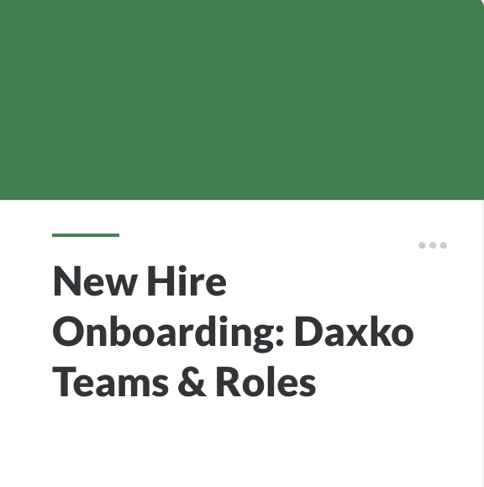 | This course, Daxko Teams & Roles, will place each leader, team, and team role in the Customer Journey framework to equip New Hires to serve internal and external customers. Knowledge of the Daxko Teams & Roles is critical to our We Over Me imperative. Your full participation in cross-team collaboration, Daxko-wide initiatives, and standardization is dependent on this knowledge.
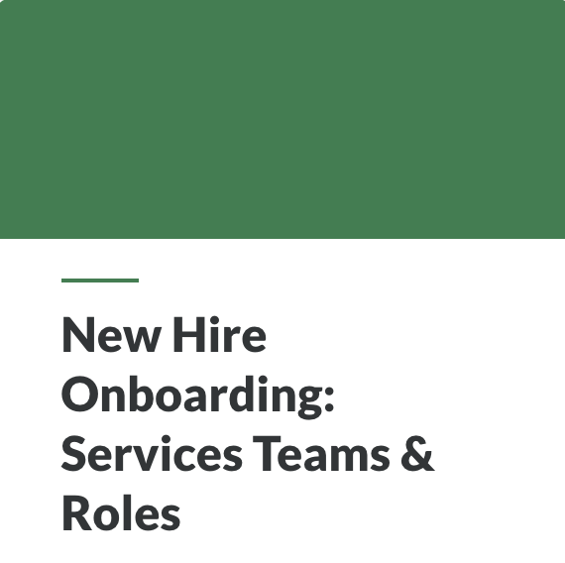 | This course, Services Team & Roles, will place each leader, team, and team role in the Customer Journey framework to equip New Hires to serve internal and external customers. Knowledge of the Services Teams & Roles is critical to our We Over Me imperative. Your full participation in cross-team collaboration, Services-wide initiatives, and standardization are dependent on this knowledge

Thursday Afternoon
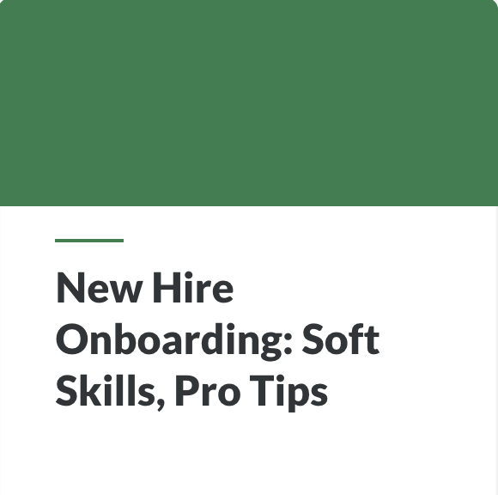 | In this course, Soft Skills: Pro Tips, you'll get an insider's look at how soft skills drive your use of Daxko's tools, communication and collaboration with others, in terms of Daxko norms and culture. Some skills are internal use only, some skills are more external, and some skills are needed in both arenas. We want this training to help you to think like an expert. In other words, beyond knowing how to do your job, you’ll need to know why you do it and when to make one choice over another.

Other Courses
- ANDON (Lo, Friday)
- Introduction to Coaching (Britta, Friday)
- Soft Skills: Critical Thinking (week 4)
- Soft Skills: Conflict Solutions (week 4)
- Soft Skill: Customer Service (Britt, Week 4)

Services Operations is fully responsible for facilitating Week One Assignments and Activities, which include:
Onboarding Assignments
Due EOD | Course | Assignment | Location
Thursday | Admin Tools | Okta SSO Screenshot | TalentLMS Upload (requires SO instructor check)
 |  | ADP Screenshot | TalentLMS Upload (requires SO instructor check)
 |  | Dropbox Screenshot | TalentLMS Upload (requires SO instructor check)
Thursday | Comm Tools | Outlook + Zoom + Slack (screenshot of meeting) | - Slack upload/reactions  - TalentLMS signature (requires SO instructor check)
Thursday | Daxko Culture | Buffalo Research | - Slack upload/reactions  - TalentLMS signature (requires SO instructor check)
 |  | Culture-Add (Diversity) reflection | TalentLMS Text reply (requires SO instructor check)
 |  | Fail Fast reflection | TalentLMS Text reply (requires SO instructor check)
Thursday | Ind Overview & Co. Intro | Our Vision Reflection | TalentLMS Text reply (requires SO instructor check)
Thursday | Soft Skills: Foundations | Growth Mindset Challenge | TalentLMS (requires SO instructor check)
Thursday | Daxko Roles & Teams | Storyline Activity + TalentLMS Test (SLT & Teams review) | TalentLMS (course completion)
Thursday | Services Roles & Teams | Your place on the Org chart | TalentLMS (requires SO instructor check)
Thursday | Soft Skills: Pro Tips | Soft Skills Self-Eval (survey) | TalentLMS (requires SO instructor check)
Friday | NEW HIRE COACHING | Self-reflection & goal setting | New Hire Coach
Monday | Platforms & Verticals | Platform/Verticals Recon | TalentLMS (requires TL or NH Coach check)
Monday | Platforms & Verticals | Customer Avatar worksheet | TalentLMS (requires TL or NH Coach check)
Please encourage and assist your New Hire in getting these assignments done (in taking advantage of this focused learning time).

